Inventory Management Tool

CS 157A Team 14

Khoa Phan

Jing Hui Ng

Renad Morrar

1. **Overview:**

Many businesses are having a problem to manage their inventory in an effective way. Our tool is to provide a friendly and useful tool in order to help those businesses be able to manage their inventory more effectively . In detail, the software will help companies to manage the stock of products with various functions such as generating reports, maintaining the balance of the inventory. Moreover, it will provide accurate information about the products without any error. In a general sense, the inventory system will work by allowing the user to manage and keep track of the stock. The most important goal that we are aiming for is providing a customer a better way to manage their business’s inventory more effectively, which will lead to save a lot of money and time for the companies.

**2**. **System Environment:**

**A. A Structure Diagram of the System:**

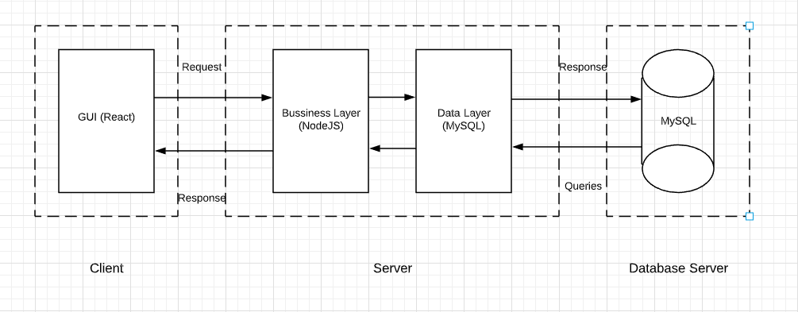

**B. Hardware & Software:**

* Back-end: **Node.js version: 10.16.3** (Javascript runtime environment), **Express.js** v4.16.1(Web application framework for node.js), **npm v6.9.0**
* Front-end: **React v3.0.1** (Javascript library for building UI), **Redux v4.0.4, Material UI v4.4.3**
* Database: **MySQL Workbench v8.0 CE**
* Misc: Any type of web browser (Chrome/Firefox/etc), Linux or Windows environment, and Wifi connect capability
* Visual Studio Code/Atom
* Git & Github
* Slack

**C. Programming/Application languages used:**

* Front-end: CSS, Javascript
* Back-end: Javascript

**5. ER Diagram Design:**

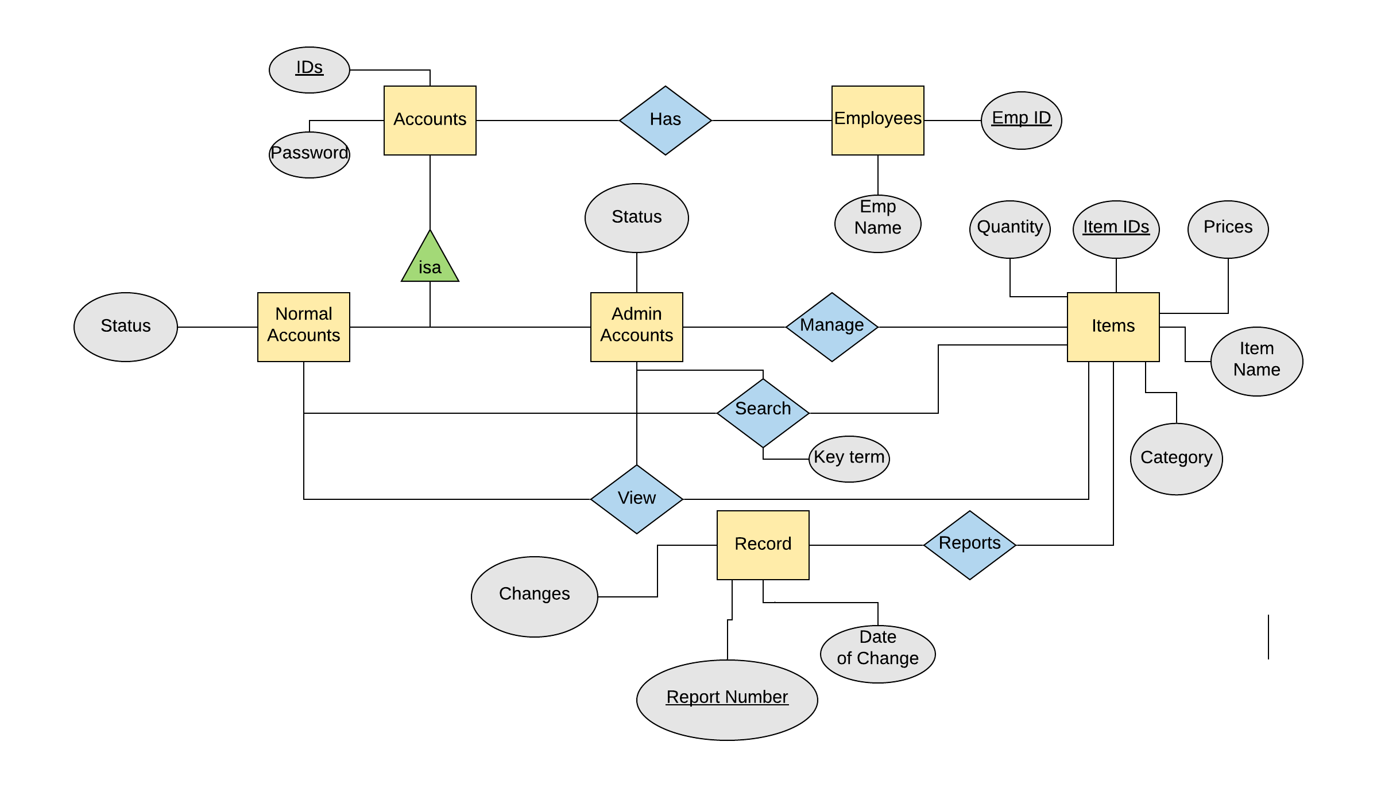

**6. ER Diagram to Schemas:**

**I. Schemas for Non-Weak Entity Sets:**

Employees(EmpID, EmpName)

Accounts(IDs, Passwords)

Normal Accounts(IDs, Passwords, Status)

Admin Accounts(IDs, Password, Status)

Items(ItemIDs, Category, Quantity, Prices, Name)

Records(ReportNumbers, Changes, Date of Change)

**II. Schemas for Non-Supporting Relationships:**

Has(EmpIDs, IDs)

Manage(IDs, ItemIDs)

View(IDs, ItemIDs)

Search(IDs,ItemIDs,Key-term)

Report(ReportNumber, ItemsIDs)